Pratyusha Thundena

Laboratory 2

FA2017 CS 103L-F4 Introduction to Computation Lab

September 22, 2017

Source Code

Figure 1:

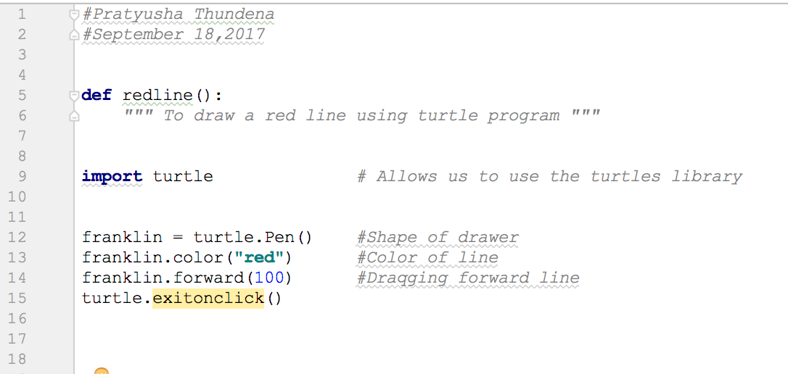

Figure 2:

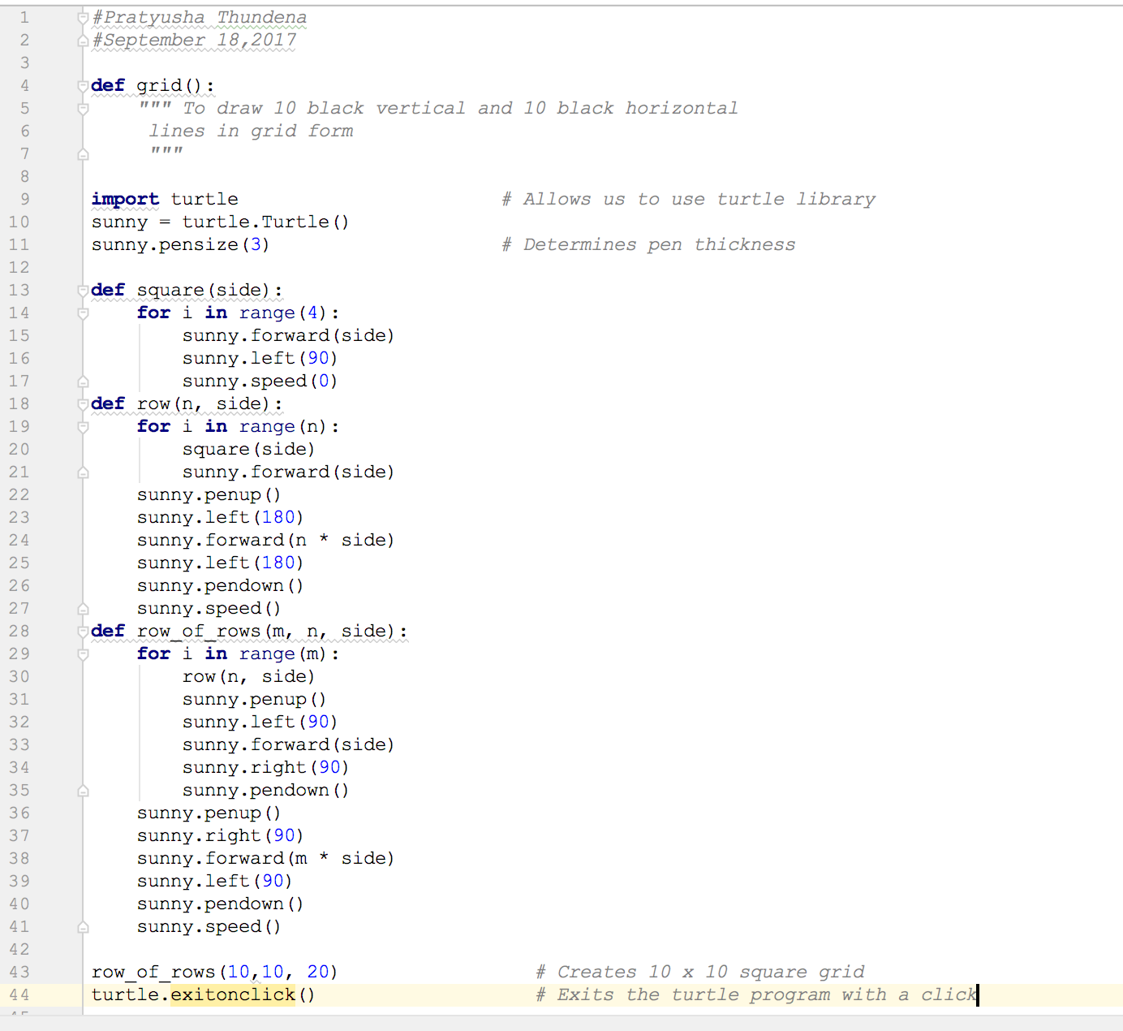

Figure 3:

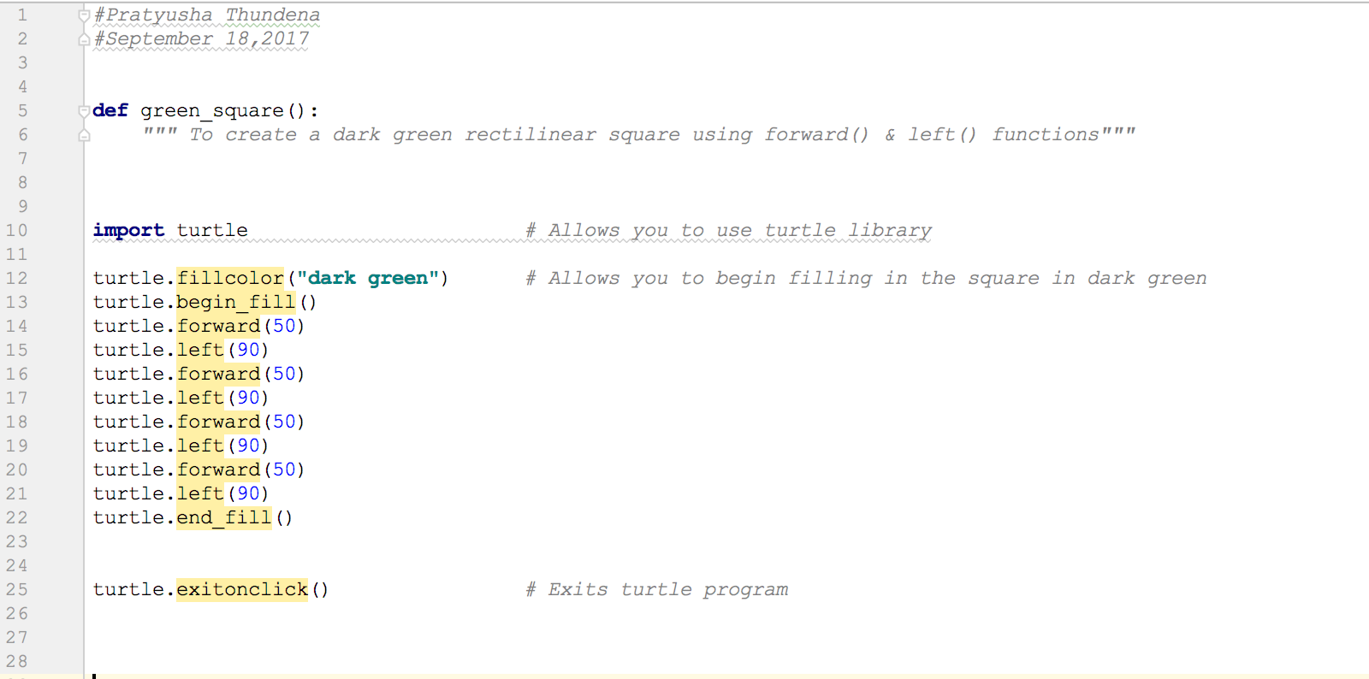

Figure 4:

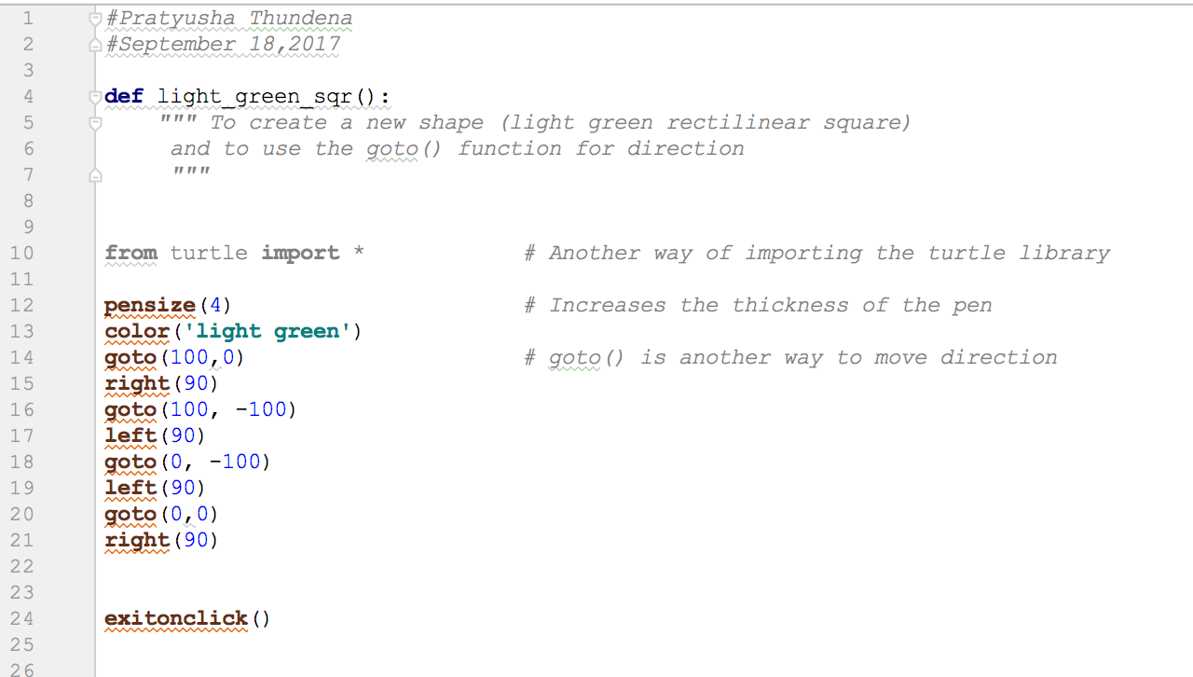

Figure 5:

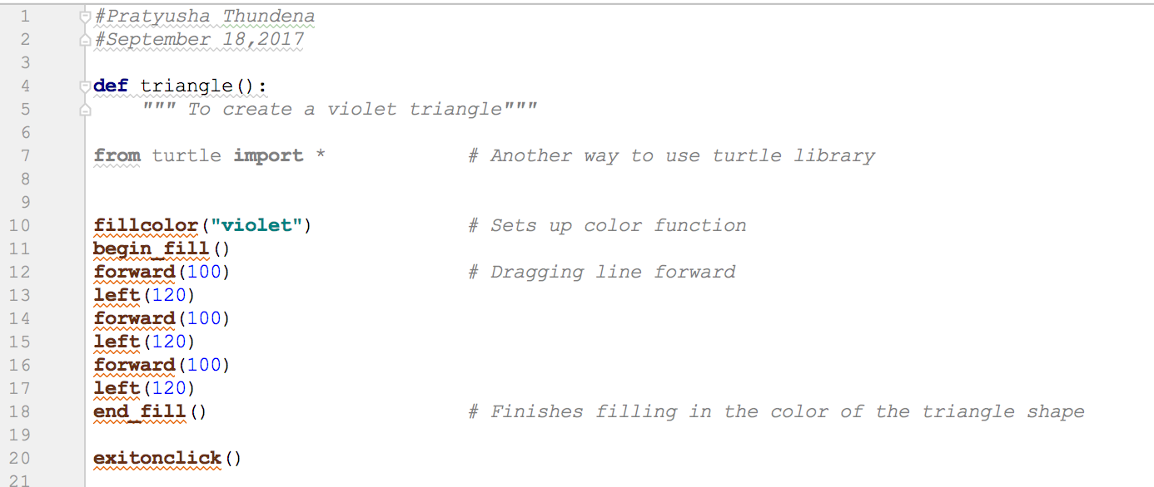

Figure 6:

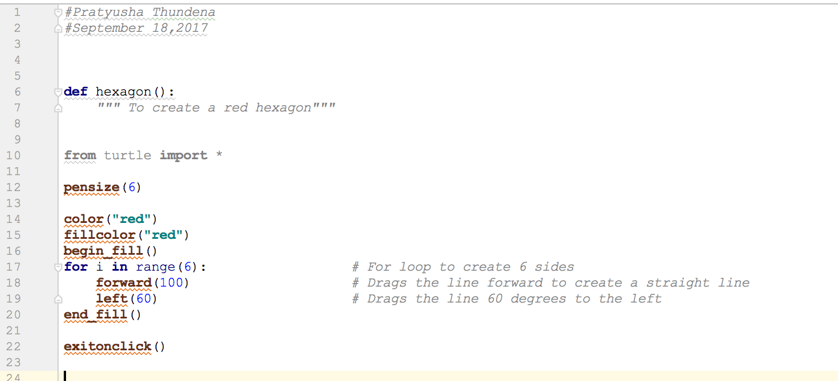

Figure 7:

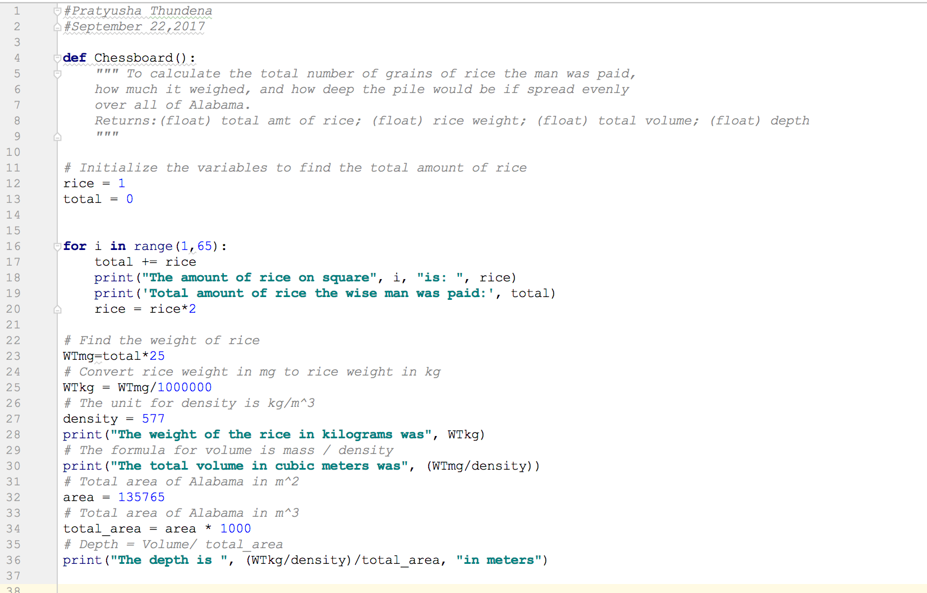

Demonstration to TA

Source codes demonstrated on 9/21/2017 at approximately 2:10 pm (CST) to BreAunna.

Program Results

Figure 1 Output:

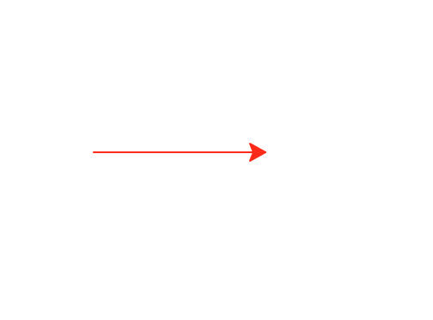

Figure 2 Output:

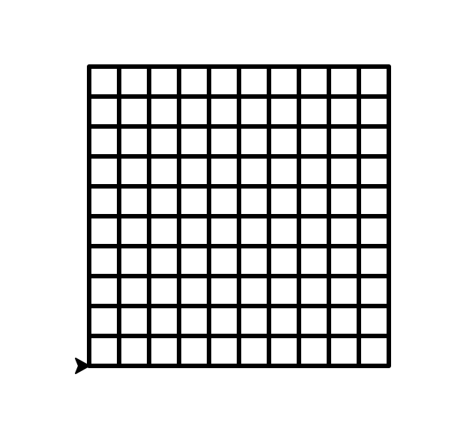

Figure 3 Output:

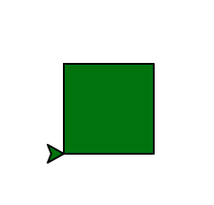

Figure 4 Output:



Figure 5 Output:

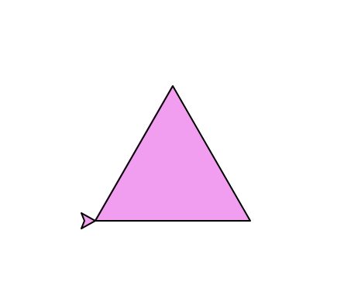

Figure 6 Output:



Figure 7 Output:

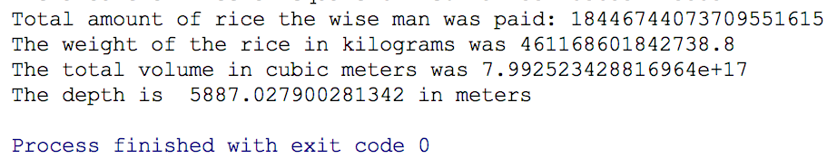

Conclusion and Results

This lab focused on learning to use Turtle graphics, which is a drawing tool used to

produce graphic designs on the screen. The idea behind the turtle part of the “turtle graphics”

was based on a hypothetical turtle holding a pen. You could issue the following commands:

import a library, control the direction of the pen, determine the pen size, select the pen color,

choose pen thickness, and etc. You could draw something as basic as a red line (Figure 1) or you

could draw something as complex as a hexagon (Figure 6). You could also use goto () command

or the forward () and left () command to accomplish the same task; specifically, creating a square

shape (Figure 3, Figure 4).

The aim of the second portion of the lab was to understand basic mathematical concepts

and to learn to setup code related to those concepts. The legend of the origin of chess involved a

ruler and a peasant. The peasant asked for the ruler for a grain of rice on the first square of

chessboard, twice as much rice on the next square, and thrice as much rice on the third square,

and so on. The ruler agreed assuming that providing the rice was easily doable. Unfortunately,

the ruler was wrong. The total amount of grain of rice he had to pay the peasant would add up to

a whopping 18,446,744,073,709,551,615 (Figure 7). In this lab, we also had to calculate the

weight of that rice, the depth of the pile of that rice spread in one even layer in Alabama (Figure

7). The biggest challenge for me was to convert to depth using the weight of the rice, density,

and total area of the rice in Alabama.